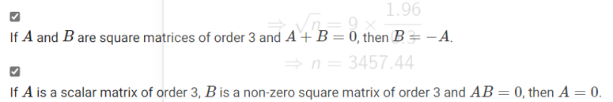



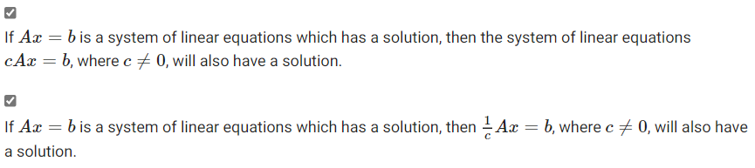

In the case of a square matrix, linearly independent columns do imply every Ax=b has a unique solution.



Then,







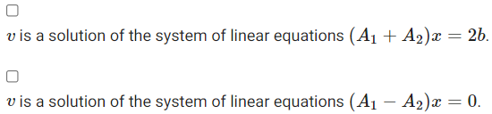



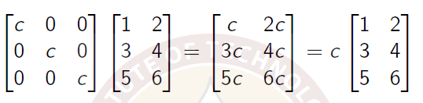

There are 3 possibilities for the solutions to a linear system of equations:

1) The system has a single unique solution. Geometrically, the representations intersect (lines in R2 and planes in R3)

2) The system has infinitely many solutions. Two or more equations could be scalar multipliers of each other. Geometrically, the representations are same/coincide (lines in R2 and planes in R3)

3) The system has no solution. Two or more equations could be contradicting to each other. Geometrically, the representations are parallel (lines in R2 and planes in R3)

- det(I) = 1

- det(AB) = det(A) * det(B)

- det(A) det(A-1) = I. Here det(A-1) is called inverse of the matrix A and is given by 1/det(A)

Type1: If you switch position of two rows (or columns) in a matrix, determinant changes its sign.

Type2: If you add multiple of one row (or a column) to another, determinant is unaffected.

Type3: If any of the rows (or columns) of a matrix is multiplied by a scalar, determinant is also multiplied by the scalar. This implies that if every row (or column) in an m * m matrix is multiplied by the scalar, the determinant is multiplied by (scalar)m

- Determinant of a matrix with a row (or column) comprising of all zeros is 0.

- Determinant of a matrix in which one row (or column) is a linear combination of other rows (resp. columns) is 0.

- Determinant of an triangular (upper/lower) matrix is products of its diagonal elements.

- Determinant of transpose of a matrix is the same as that of the original matrix.

- Determinant of a product of matrices is the product of its determinants.

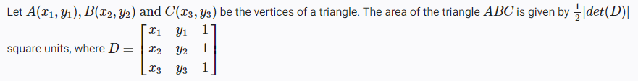

Suppose for a real 3 * 3 matrix A, there exists a real 3 * 3 matrix P such that D = PAP-1 is a real 3 * 3 diagonal matrix. In that case,

- det(A) must be equal to det(D)

- If D is an identity matrix of order 3, A must also be an identity matrix of order 3.

Cramer’s rule

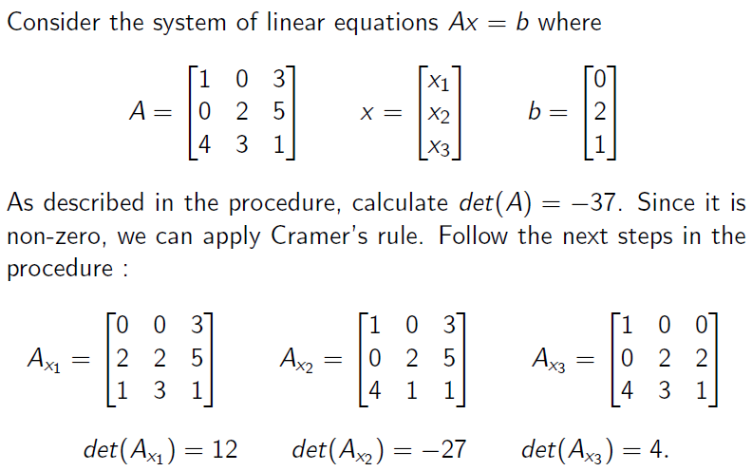

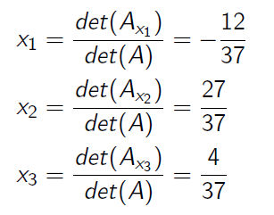

Inverse of a matrix exists, only if its determinant is non-zero. This is because, by definition, AA-1=I, which implies det(A-1) = 1/det(A).

Finding the inverse of a matrix

* Find the determinant of the matrix. Call this *d*
* Find the adjugate of the matrix (transpose of the cofactor matrix). Call this *Adj*
* Inverse = *Adj / d*

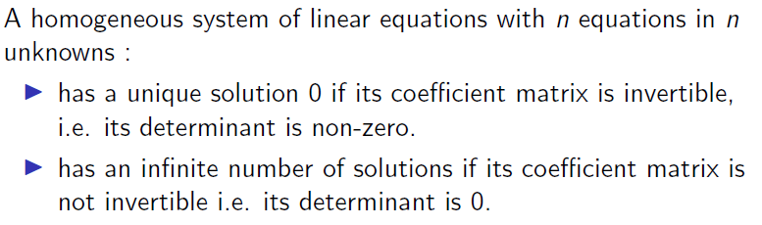





Adjoint of Identity matrix (or zero matrix) is same as the original matrix.













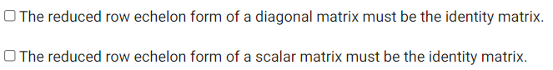

For homogeneous system of linear equations, there are only two possibilities:

1. 0 is the unique solution. This is called trivial solution.
2. There are infinitely many solutions other than 0.

In a homogeneous system of equations, if there are more variables than equations, then it is guaranteed to have nontrivial solutions.

# Vector spaces

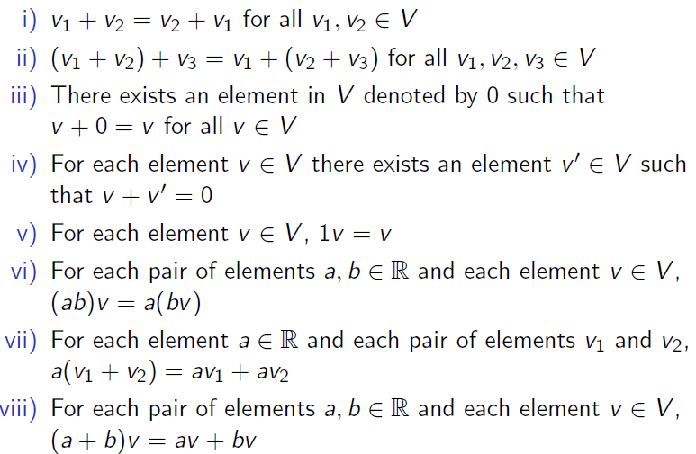

How to check if a given vector space (subspace) is valid or not?

If all vectors in the space are closed under addition or scalar multiplication, then the given vector space is valid.







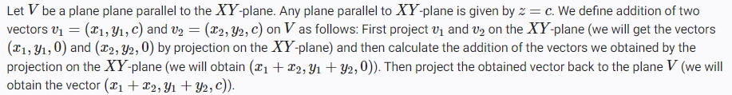

When v1 is projected to XY plane, we get (1,2,0). When v2 is projected to XY plane, we get (0.3,0)

When v1 is added to v2, we get (1, 5, 2)



Set of vectors containing the 0 vector is always dependent, since it can produce non-trivial solutions for linear combinations amongst them.





Then,







Rank is the number of elements in the basis of a vector. It’s the number of non-zero rows, when vectors are represented as rows. It’s the number of non-pivot elements, when vectors are represented as columns

Nullity is the number of independent elements when the vectors are represented as a matrix.

Nullity + Rank = number of columns.

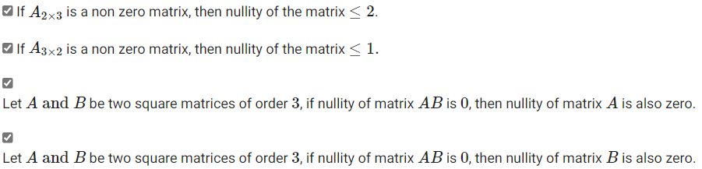



Then,

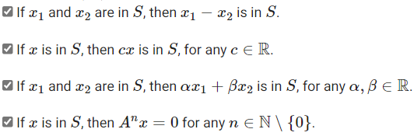



Then,





Then,















*Following is not possible:*



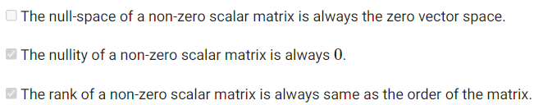

*Linear Transformation*

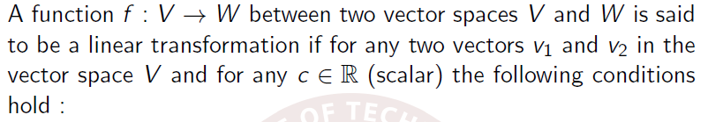

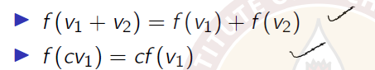

In a linear transformation, output vectors can be represented as a linear combination of input vectors. The coefficients of this linear combination (c1, c2, .., cn) can be used to compute transformation of a vector from one space to another.

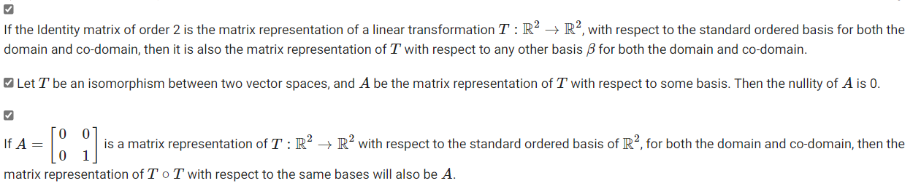

In a linear transformation problem,

Beta vectors is the set of vectors in the input vector space.

Gamma vectors is the set of vectors in the output vector space.

Transformation of each Beta vector is a linear combination of Gamma vectors. The resulting coefficients for one column of the transformation matrix.

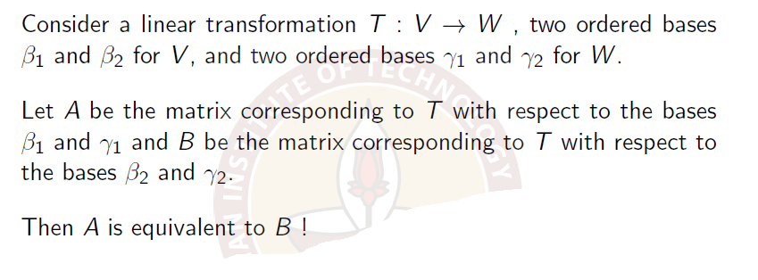

If A = QBP, then A and B are called equivalent. If A = P-1BP, then A and B are called similar matrices.

If A is equivalent (or similar) to B, B is also equivalent to A.

A equivalent (or similar) to B ***and*** B equivalent (or similar) to C ***implies*** A equivalent (or similar) to C.

Ranks of equivalent (or similar) matrices are equal.

Determinants of equivalent (or similar) matrices are equal.

Equivalent matrices can be transformed between each other using elementary row/column operations.